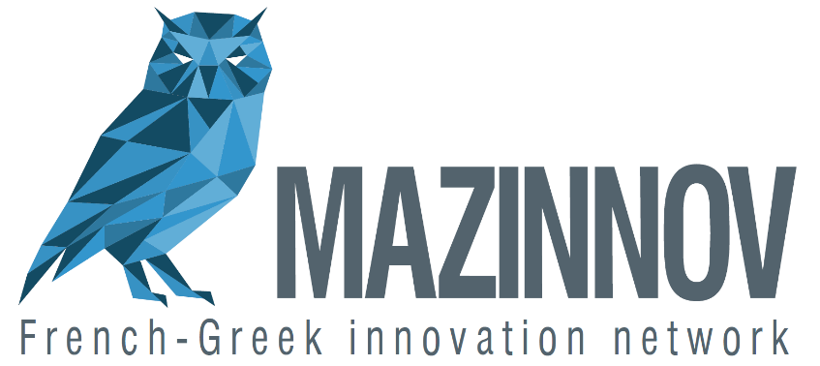

Forum MAZINNOV 2
Adopt a startup / Imagine the Greece of tomorrow
Call for applications

The second edition of the French-Greek innovation forum MAZINNOV will take place in Athens on November 10th and 11th of 2017. The two key features of this forum will be:

- ADOPT A STARTUP:
French and Greek companies will adopt startups even at their early stage, offering them their support (providing advices, networking, and development assistance).
You are a startup and you want to be adopted? Send your application in a video format presenting your project (one minute) with the following form.
The adopting companies and the adopted startups will be presented to the audience at the forum, on Friday, November 10th of 2017.

2- IMAGINE THE GREECE OF TOMORROW:
You have an idea to imagine the Greece of tomorrow, in one of the following topics: Agriculture, Tourism, Environment, Energy, Reform of the State, Shipping, Finance, Handicap, the place of art in the workplace.
Send your application in a video format presenting your idea (one minute) with the following form.You will have 3 minutes to pitch1 your idea at the forum on Saturday, November the 11th, at the end of which a jury will vote for the most promising ideas.

Startups can apply for both programs “Adopt a startup” and “Imagine the Greece of tomorrow”.
Application form for ADOPT A STARTUP
(to fill up in English)

1/ Name of your startup:

2/ Contact information of your startup (address - phone number- e-mail address):

3/ First and last names, title of the representative:

4/ Activity area:

5/ Description of the startup (2000 characters maximum):

6/ Expression of your needs (500 characters maximum):

7/ Language spoken for the pitch:

Deadline for applications: September 30th of 2017.
Applications to be sent by email to apply@mazinnov.com
Please attach your video (using wetransfer or .mov).

Application form for IMAGINE THE GREECE OF TOMORROW
(to fill up in English)

1/ First and last names:

2/ Contact information (address - phone number - e-mail address):

3/ Current activity:

4/ Chosen topic (1 possible choice):
Agriculture
Tourism
Environment
Energy
Reform of the State
Shipping
Finance
Handicap
The place of art in the workplace

5/ Idea’s short presentation (100 characters maximum) :

6/ Idea’s description (2000 characters maximum) :

7/ Language spoken for the pitch:

Deadline for applications: September 30th of 2017.
Applications to send by email to apply@mazinnov.com
Possibility to attach a document displaying your idea (picture, video,..). NON MANDATORY

Languages: French, Greek or English.

